**Chapter 1**

**Introduction**

In the realm of virtual reality (VR) and augmented reality (AR), immersive experiences bring the power of visualization to life. Among the various themes explored within this domain, natural phenomena like volcanic eruptions stand out for their dynamic and awe-inspiring visuals. This report delves into the creation process of an AR/VR project centered around a volcanic eruption using Blender, a versatile 3D modeling and animation software.

* 1. **Overview**

The project aims to simulate a realistic volcanic eruption within a virtual environment, leveraging the capabilities of Blender to craft intricate landscapes, fluid dynamics, particle systems, and material shaders. Through meticulous attention to detail and advanced techniques, the objective is to immerse users in an experience that captures the intensity and grandeur of a volcanic event.

* 1. **Problem Statement**

Creating a convincing volcanic eruption in AR/VR environments presents several challenges. From crafting realistic terrain to simulating fluid dynamics and smoke effects, each element must seamlessly come together to evoke a sense of authenticity. Additionally, optimizing performance without sacrificing visual fidelity is crucial to ensure smooth playback on various hardware configurations.

* 1. **Objectives**
* Terrain Creation and Realism: Develop a volcanic landscape using Blender's landscape add-on and sculpting tools, focusing on realistic terrain features such as craters, ridges, and rocky textures.
* Simulation of Volcanic Activity: Utilize Blender's fluid and particle systems to simulate lava flows, sparks, and ash clouds, incorporating dynamic movement and interactions for added realism.
* Material and Shader Development: Create custom shaders and textures to depict volcanic rock, lava, smoke, and atmospheric effects, enhancing visual fidelity and immersion.
* Optimization and Performance: Implement strategies to optimize the project for efficient rendering and playback, ensuring a smooth experience across different AR/VR platforms and devices.
* By addressing these objectives, the report aims to provide insights into the technical and creative processes involved in developing an AR/VR project focused on the captivating phenomenon of a volcano eruption.

**Chapter 2**

**System Requirements**

* 1. **Hardware Requirements**
* RAM: Minimum 16GB RAM (32GB or higher recommended) to handle complex simulations and rendering tasks smoothly.
* Graphics Card: Dedicated GPU with at least 4GB VRAM (NVIDIA GeForce GTX 1060 or AMD Radeon RX 580 recommended) for real-time viewport rendering and fluid simulations.
* Storage: SSD storage (500GB or more recommended) for fast loading of large project files and simulations.
* Display: Full HD (1920x1080) or higher resolution monitor for detailed visualization and editing.
  1. **Software Requirements**
* Blender: Latest version of Blender software (Blender 3.0 or newer) for 3D modeling, animation, fluid simulation, and rendering.
* Operating System: Compatible with Windows 10, macOS, or Linux operating systems.
* Additional Plugins/Add-ons: Installation of necessary Blender add-ons/plugins like landscape add-on, node wrangler, and regular node add-on for efficient workflow.
* Image Editing Software: Optional but recommended image editing software (e.g., Adobe Photoshop or GIMP) for texture creation and manipulation.
* HDR Environment Maps: High-quality HDR environment maps for realistic lighting setup in the scene.
* Compositing Software: Optional compositing software (e.g., Adobe After Effects or Nuke) for post-processing effects and final adjustments to the rendered footage.
* ARVR Development Tools (Optional): ARVR development SDKs or platforms (e.g., Unity, Unreal Engine) if integrating the project into ARVR environments for immersive experiences.

**Chapter 3**

**System Design & Implementation**

**3.1 System Design**

**Modelling and Simulation Component:**

* This component encompasses the creation of the volcano model, landscape, and various simulation aspects such as particle, fluid, and smoke simulations.
* Volcano Model: Creating the volcano model using Blender's landscape add-on and sculpting tools.
* Terrain Simulation: Utilizing Blender's simulation capabilities to simulate volcanic activities like lava flow, smoke emission, and ash dispersion.
* Particle System: Configuring particle systems for sparks, lava splatters, and other effects associated with volcanic eruptions.
* Fluid Simulation: Setting up fluid dynamics for lava flow simulation within the volcano model.

**Material and Texture Component:**

* This component involves creating and applying materials and textures to various elements of the scene to achieve realistic visual effects.
* Texture Mapping: Mapping textures onto the terrain and other objects using UV mapping techniques.
* Material Design: Developing shaders and materials for the terrain, rocks, lava, smoke, and other elements to achieve the desired visual appearance.
* Emission and Lighting: Adjusting emission strength, color, and lighting settings to simulate the glowing effect of lava and enhance overall scene illumination.

**Animation and Keyframing Component:**

* This component focuses on animating various elements within the scene to simulate dynamic volcanic activity.
* Keyframing: Setting keyframes to control the timing and behavior of animations, such as lava bursts, fluid flow, and particle movement.
* Animation Control: Fine-tuning animation parameters such as velocity, direction, and fluid emission rate to achieve realistic motion and behavior.

**Simulation Optimization Component:**

* This component involves optimizing simulations and rendering settings to ensure smooth performance and realistic visual output.
* Simulation Parameters: Adjusting simulation settings such as resolution, speed, and boundary conditions for optimal performance and visual quality.
* Rendering Optimization: Optimizing rendering settings, including resolution, sampling rates, and output formats, to reduce rendering time and resource consumption.

**Compositing and Post-processing Component:**

* This component deals with post-processing effects and compositing techniques to enhance the final rendered output.
* Compositing Effects: Adding effects such as mist, glow, and color correction to the rendered frames using Blender's compositing nodes.
* Post-processing: Applying additional effects or adjustments to the final output to improve overall visual quality and realism.

**Testing and Iteration Component:**

* This component involves testing the project at various stages of development and iterating based on feedback to improve overall quality and performance.
* Testing: Conducting thorough testing of simulations, animations, materials, and rendering settings to identify and address any issues or inconsistencies.
* Iteration: Iteratively refining and optimizing the project based on feedback from testing and evaluation to achieve the desired outcome.
  1. **System Implementation**
* Create a volcano with landscape add-on and simulations: Covering particle, fluid, and smoke simulations. Using the landscape add-on to create a volcanic landscape.
* Adjust terrain parameters to create realistic landscape: Modify mesh scale and height to control terrain bumps and plateau. Experiment with noise size, options like 'Rigid Ridge', and subdivision for volcanic look.
* Creating a volcanic landscape in sculpt mode: Using the sculpt draw brush to create a volcanic hole and shape the landscape. Exploring techniques such as turning off X mirror and using the grab brush for detailed effects.
* Using sculpt draw brush to create rocky, harsh looking stone texture: Pinching edges to create a more detailed, rocky texture. Switching to sculpt draw brush to add more detail and create the lava hole.
* Tips for keeping terrain simple for better performance: Relative detail tip for sculpting in Blender. Adjusting camera position for realistic volcano shot.
* Adding more detail to the sculpting process: Adjusting the camera angle and position for better visualization. Adding realistic details by referencing volcanic rock and adding creases and peaks.
* Creating a collision mesh for fluid simulation: Using the decimate modifier to reduce the face count. Setting up the collision properties in the physics tab.
* Setting up collisions and particle system for volcano simulation: Choosing no slip for lava to make it sticky. Adding wind force field for a natural look.
* Adjusting particle settings for volcano sparks: Reducing gravity to 0.1 to make particles float and move freely. Setting random speed, emission along Z-axis, and Brownian motion for variation.
* Adjusting particle settings for wind and lifetime in Blender: Fine-tuning wind effects and random variation speed for particle motion. Setting particle lifetime, random lifetime, and gravity pull for natural particle movement.
* Open and apply a splatter image texture to the mesh: Ensure to uncheck the 'limiting selection to visible' option. Use 'project from view bounds' for proper aspect ratio and scale.
* Adding and positioning image textures on the mesh: Select cycles render for material addition to access all options. Adjust texture position and scale in real-time for desired visual effect.
* Using texture as a mask for emission: Creating a shader with emission and surface hook-up for the ground texture. Adjusting the colors and inverting results using RGB curves and color ramp for flame material.
* Adjusting texture and shader settings for volcanic look: Using an image texture for a volcanic rock appearance, and modifying its colors. Enabling the node regular add-on to speed up workflow and facilitate node connections.
* Adjusting texture coordinates and fixing UV map issues for the ground texture: Using math to adjust texture brightness and intensity. Fixing UV map issues by setting ground UV map and addressing mesh holes.
* Adjust environment texture for better lighting: Switch to world settings and use HDR for lighting. Adjust the position of the environment texture using texture coordinate and mapping nodes.
* Adjusting the lighting and color management for the scene: Experimenting with the lamp strength, angle, and color for the desired effect. Setting the color management for achieving the desired film look.
* Creating realistic volcanic rock material in Blender: Using shader mix and glossy shader to achieve the right glossiness. Adding bump and adjusting color to create a dark volcanic rock with a slight bluish hue.
* Adjust particle size, divide age by lifetime and apply color ramp for particle system: Change particle scale and randomness for object rendering. Set up color ramp to differentiate between new and old particles.
* Adjusting shaders for realistic volcano effect: Using mix shader and transparent shader for fading effect. Adding motion blur for realistic spark trails.
* Creating fluid and smoke simulations in Blender: Setting up the fluid domain and particle object for the simulation. Configuring the fluid object as inflow to add fluid to the scene.
* Keyframing the fluid simulation for bursts of lava: Setting keyframes to control when the simulation is enabled and disabled. Adding keyframes for velocity and direction to create the desired fluid movement.
* Adjusting fluid emitter settings for animation: To create more lava splatters, duplicate and adjust keyframes on the fluid emitter. Settings such as amount, direction, and position can be changed for each keyframe.
* Adjust fluid simulation settings for scale and speed: Set simulation speed to 0.8 to create a slower, larger-scale fluid look. Adjust fluid boundary, subdivisions, and particle generation for desired results.
* Creating the material for the fluid in Blender: Adjusting the emission and volume absorption shaders for the fluid. Applying the glass material with specific color and density for the fluid.
* Adjusting fluid parameters for a realistic look: Customize the color of the glass and vial for desired effect. Fine-tune emission shader and density for realistic fluid appearance.
* Managing force fields and turbulence for particle systems: Consider adding force fields to separate layers to avoid unwanted influences on particle systems. Adjust particle settings to turn off any influence that turbulence might have on the particle system.
* Adjusting smoke and ash settings for better simulation: Setting smoke group attributes such as end frame and high resolution. Tweaking turbulence strength and size for simulation improvement
* Optimizing high-resolution smoke for better framerate: Uncheck 'show high-resolution smoke' for improved performance in viewport. Use shader, volume absorption, input attribute, and math nodes to control smoke density and appearance.
* Adjusting the color of the smoke and fluid in Blender: Adding a reddish emission color to the smoke emitter to simulate light from the lava. Adjusting contrast of the smoke material and tweaking the color of the fluid for a better look.
* Process of baking and rendering the smoke and particles: The smoke simulation and particle simulation were baked and checked for quality. Adjusting render settings and preparing for the final render with compositing effects.
* Applying compositing to improve the volcano rendering: Using a misty vector map value for the mist effect. Adjusting the minimum and maximum values to match the colors and size for better effects.
* Creating different types of glows using Blender: Adjusting the values for sparks and glow effects. Adding a wide glow using color ramp and blur.
* Adjusting glow and mist for better results: Reducing glow amount and blurring for finer details. Adjusting color balance and mist factor for better color and contrast.
* Adjust emission strength and mist for volcano eruption in Blender: Using the node editor to adjust emission strength and reduce brightness in the center. Adding more mist to enhance the overall look of the volcano.
* Adding Audio of Volcano Eruption to the Animation in Blender: Importing a suitable audio file of a volcano eruption into Blender's sequencer. Syncing the audio with the animation timeline to match the eruption sequence. Adjusting the volume and pitch of the audio to create a realistic effect. Utilizing keyframes to control the audio's intensity throughout the animation. Adding additional sound effects, such as rumbling or cracking, to enhance realism. Testing the audio alongside the animation to ensure synchronization and effectiveness. Exporting the final animation with the integrated audio for presentation or further editing.

**Chapter 4**

**Results**

The ARVR project on "Volcano Eruption" utilizing Blender application has yielded impressive results, showcasing a comprehensive blend of creative design, meticulous simulation, and technical execution. The project has successfully encapsulated the dynamic and dramatic spectacle of a volcanic eruption, leveraging a multitude of tools and techniques within Blender. Below are the key results observed throughout the project implementation:

* **Realistic Volcanic Landscape:** Utilization of landscape add-ons and sculpting techniques resulted in the creation of a visually striking volcanic landscape. Fine-tuning of terrain parameters and texture mapping facilitated the generation of realistic terrain features such as rugged rocks, lava holes, and volcanic peaks.
* **Dynamic Fluid and Particle Simulations:** Implementation of fluid simulations for lava flow and particle systems for volcanic sparks contributed to the dynamic nature of the eruption. Adjustments to particle settings, including velocity, lifetime, and randomness, enhanced the realism and variation of particle behaviour.
* **Convincing Visual Effects:** Application of shaders, emission, and volumetric effects produced convincing visual representations of lava, smoke, and ash. Experimentation with compositing and post-processing techniques added depth and atmospheric effects, enhancing the overall visual impact.
* **Performance Optimization:** Consideration of performance optimization techniques such as mesh decimation, particle system adjustments, and smoke simulation optimization ensured smooth playback and rendering performance.
* **Realism and Immersion:** Attention to detail in texture mapping, shader adjustments, and lighting configurations contributed to the realism and immersive quality of the simulation. Integration of mist effects, glows, and color grading further enhanced the atmospheric realism, drawing viewers into the immersive volcanic environment.
* **Artistic Expression and Technical Proficiency:** The project demonstrated a balance between artistic expression and technical proficiency, showcasing the versatility and capabilities of Blender as a comprehensive 3D creation tool.

**Project Outcomes :**

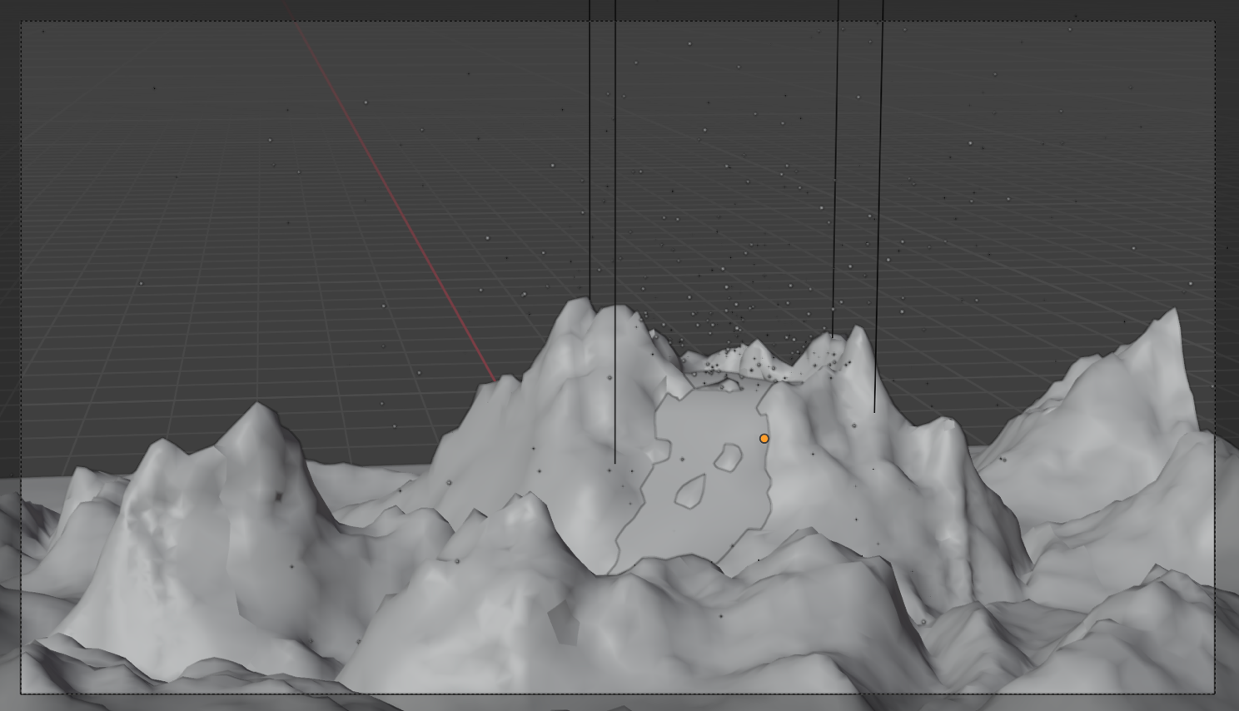

Figure 4.1 : Volcanic Mountain in Solid Mode

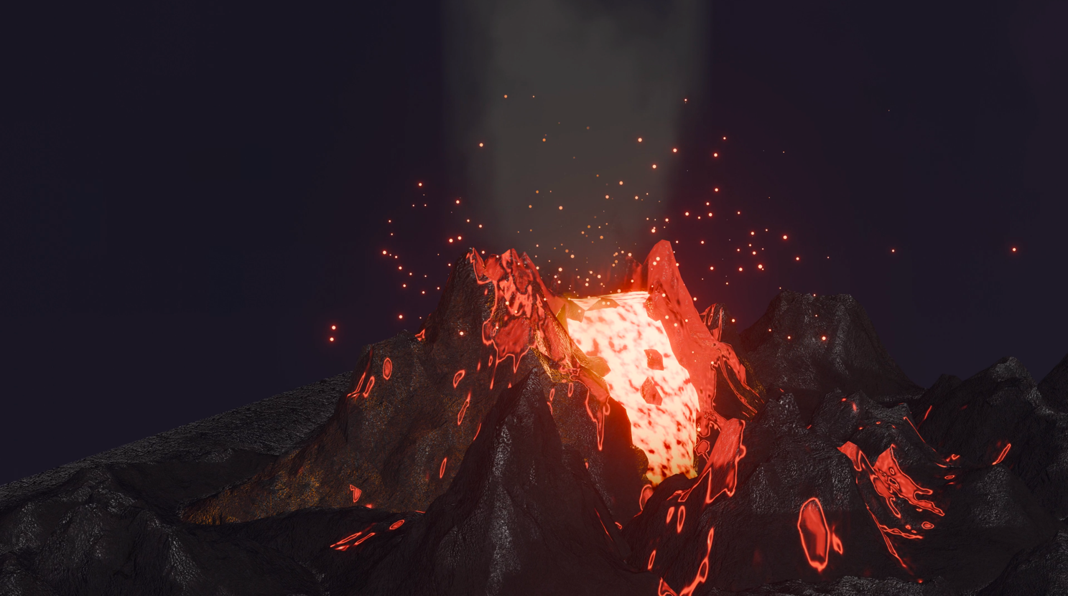

Figure 4.2 : Volcanic Mountain in Render Mode

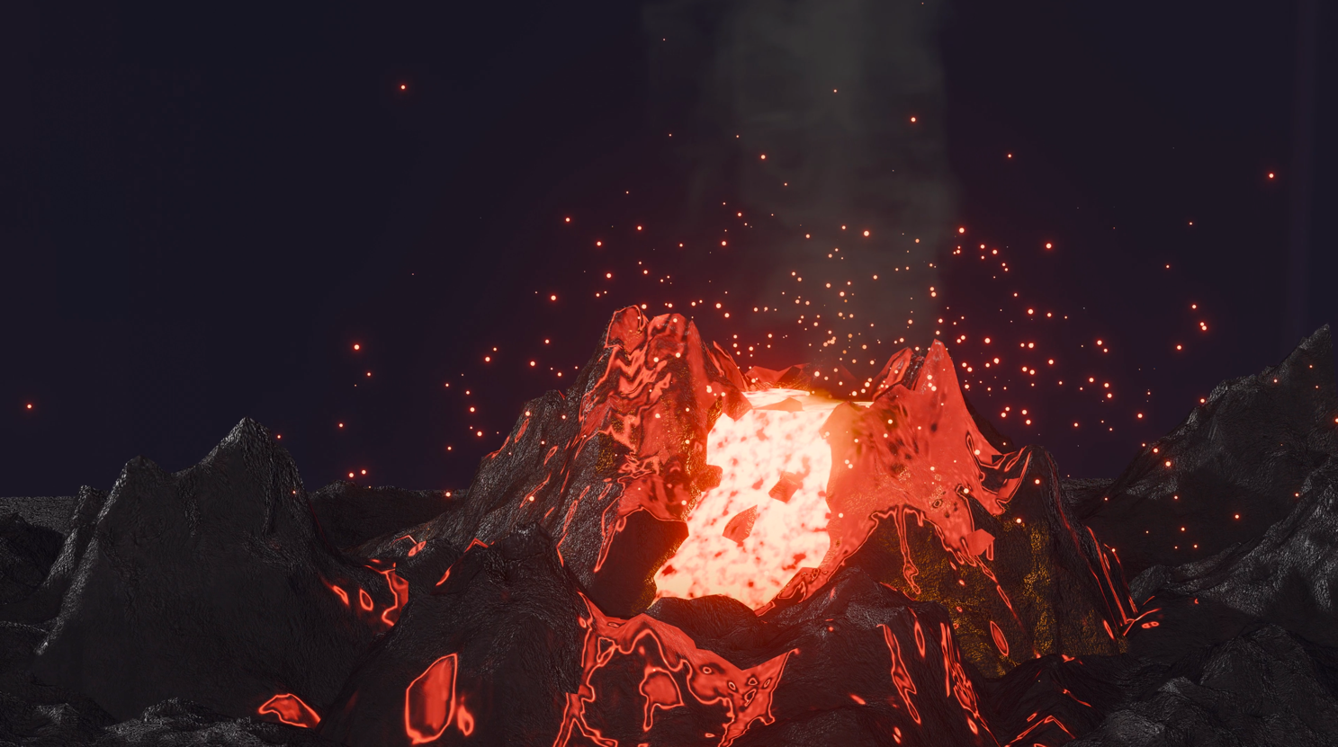

Figure 4.3 : Volcano Eruption in Render Mode

**Chapter 5**

**Conclusion & Future Enhancement**

* 1. **Conclusion**

The creation of a volcano eruption project using Blender application involved a comprehensive series of steps covering various aspects of 3D modelling, simulation, texture mapping, material creation, lighting, and rendering. Through meticulous attention to detail and iterative adjustments, a visually compelling and realistic depiction of a volcanic eruption was achieved. The project began with the creation of the volcanic landscape, utilizing Blender's landscape add-on and sculpting tools to shape the terrain realistically. Techniques such as adjusting mesh parameters and employing sculpting brushes helped in creating intricate details like rocky textures and lava holes. Simulations for fluid, smoke, and particle systems were meticulously set up to simulate the dynamic behaviour of a volcanic eruption, including lava flows, sparks, and ash clouds. Texturing and shading played a crucial role in enhancing the realism of the scene, with careful consideration given to the materials of volcanic rock, lava, smoke, and ash. Creative use of image textures, emission shaders, and color manipulation techniques added depth and vibrancy to the visuals. Lighting was adjusted to create dramatic effects, with the incorporation of HDR environment textures for realistic illumination. The optimization of simulations and rendering settings ensured smooth playback and high-quality output, while compositing effects like mist and glow added atmospheric depth to the final render. Keyframing and animation techniques were employed to control the timing and intensity of the volcanic eruption, adding to the overall dynamic nature of the scene. In conclusion, the ARVR project on "Volcano Eruption" demonstrated the power and versatility of Blender as a tool for creating immersive and engaging virtual experiences. Through a systematic workflow encompassing various stages of production, a realistic and visually stunning depiction of a volcanic event was achieved, showcasing the capabilities of 3D technology in educational and entertainment contexts.

* 1. **Future Enhancements**
* Enhanced Realism: Incorporating advanced shader techniques such as subsurface scattering for more realistic materials, and further refining textures to add finer details to the landscape and volcanic rocks.
* Interactive Elements: Introducing interactive elements within the AR/VR environment, allowing users to interact with the simulation, for example, triggering different stages of the eruption or adjusting parameters such as fluid flow or particle density.
* Optimization: Continuously optimizing the project for performance, especially in AR/VR environments where resources are limited. This could involve refining simulation parameters, reducing polygon count, or implementing level-of-detail techniques.
* Dynamic Environment: Adding dynamic elements such as changing weather conditions, time of day, or environmental effects like rain or ashfall to create a more dynamic and immersive experience.
* Multiplatform Support: Ensuring compatibility across various AR/VR platforms and devices, optimizing the project for performance and usability on different hardware configurations.
* Collaborative Features: Implementing collaborative features to allow multiple users to experience and interact with the simulation simultaneously, fostering collaboration and engagement in educational or entertainment settings.
* Accessibility: Considering accessibility features to make the AR/VR experience inclusive for users with disabilities, such as providing alternative input methods or audio descriptions for visually impaired users.
* Integration with Learning Content: Integrating educational content about volcanoes, geological processes, and safety measures during eruptions to make the project not only entertaining but also informative and educational.
* Feedback Mechanism: Implementing a feedback mechanism to gather user feedback and improve the project based on user preferences and suggestions, ensuring continuous refinement and enhancement.
* Exploration of New Technologies: Exploring emerging technologies such as machine learning for procedural generation of landscapes, or integrating ARCore and ARKit for augmented reality experiences on mobile devices, to push the boundaries of what's possible in AR/VR content creation.

**References**

* <https://www.youtube.com/watch?v=hArdXI2VY20&t=1s>
* <https://www.youtube.com/watch?v=pR0k1XOBvwo&t=1502s>